COVID-19 Experience Survey Narrative Summary
Prepared by: Hala Alnagar, Maria Ramirez Loyola, and Cinnamon Danube
This report summarizes the findings from the COVID-19 Experience Survey, which was created by the People First Workgroup to evaluate and respond to the experiences and needs of the UC Merced campus community during the COVID-19 pandemic. This survey was administered to Senate and non-Senate faculty, staff, postdocs, and graduate students in May 2020. For more information about the People First Workgroup, please visit this webpage.
Executive Summary
This summary focuses on themes that emerged from the survey responses. For each theme, we provide a narrative summary of the responses and note when they applied to particular respondent types. Finally, in response to the narrative summary, we make recommendations for consideration. Because this is a high-level summary, we make several general recommendations and comments:
- Data Exploration. We encourage supervisors and leadership to explore the survey dashboard to identify patterns that may help with supporting specific units/divisions, as there was variability. The People First Workgroup is happy to assist with reviewing survey data and planning approaches for sharing and discussing survey results with individual units as needed. To request a consultation, please visit this webpage and complete the form.
- Consistent Survey/Assessment Efforts. We recommend follow up survey efforts at consistent intervals to continue to examine the issues identified on this survey and better understand whether efforts to address them are effective. Follow up survey efforts should be in conjunction with other assessment efforts and a broader campus plan for administering consistent campus climate/experience surveys. The Office of Equity, Diversity and Inclusion (EDI) is currently collaborating on an implementation plan at the campus level. These efforts are particularly important as we can likely expect a protracted time of uncertainty and profound change in how we live and work as a result of the COVID-19 pandemic.
- Focus Groups and Current Efforts. The EDI Office is currently conducting virtual focus groups with staff, graduate students, postdocs, and Senate and non-Senate faculty to better understand survey responses and the needs of the campus community. Focus group topics are denoted with an asterisk (*) in table below. Finally, it is important to note that this survey was administered in May 2020 such that there have been changes. Thus, along with recommendations, we note current efforts to address some needs identified from the survey.
Theme | Narrative Summary | Recommendations and Current Efforts
Campus Resources & Response | - All: had positive feedback about the campus response to and management of the pandemic  - All: believe the campus cares about their well-being  - All: expressed a lack of awareness and/or use of resources* | Recommendations  - Continue to engage in practices that are working well (e.g., Chancellor’s Weekly Briefing)  - Improve awareness and accessibility – including language accessibility – of campus resources  - Engage in assessment to better understand resource effectiveness
Work | - All: said their needs for equipment and technology to support remote work were generally met  - All: noted additional care responsibilities (childcare, elder/adult care, schooling for children)*  - All: noted decreases in work productivity (what they are able to do)  - All: noted ergonomic challenges*  - Senate faculty, postdocs, & graduate students: were concerned about decreased research productivity*  - Non-Senate faculty: noted increased workloads (what they were asked to do)*  - Senate faculty, postdocs, & graduate students: were concerned about professional development opportunities* | Recommendations  - Continue to support equipment & technology needs as plans to work from home are prolonged  - Adjust workload and productivity expectations during pandemic  - Acknowledge and provide support and flexibility for additional responsibilities at home, which are likely to be worse now that a new K-12 school year will begin under these conditions  - Develop strategies for addressing ergonomic challenges in the home work environment  - Consider ways to support or adjust expectations for research productivity for Senate faculty, postdocs, and graduate students  - Examine inequities in increased workloads for non-Senate faculty  - Consider ways to provide professional development opportunities during this time  Current efforts  - Staff: there are resources in development for supervisors/managers to ensure maximum flexibility for working parents  - Faculty: CAP memo sent to faculty and Deans emphasizing that concerns around research productivity will be acknowledged; pre-tenure faculty can stop the clock  - Graduate students: waived 12 semester maximum; provided 1-2 additional years to complete degree and make satisfactory academic progress  - All: developing and increasing awareness of internal professional development opportunities; encouraging engagement with peers within one’s discipline/field; encouraging engagement with LinkedIn Learning
Economic Concerns | - All: were concerned about spouse/partner employment*  - Non-Senate faculty, postdocs, & staff: were concerned about job security and compensation/salary  - Graduate students: were concerned about losing funding and not being able to find a job* | Recommendations  - Consider how to support those who already experience precarious job security and/or compensation/funding, which is heightened by the pandemic  - Continue to develop strategies for supporting graduate students who are concerned about employment after graduation as COVID-19 has exacerbated this existing issue  - Continue to provide timely communication about financial impacts
Connection | - All: said that the need for supervisor-employee, mentor-mentee, and team connections were generally met  - All: expressed concerns about feeling isolated from friends and colleagues  - Faculty: expressed concerns about effectively mentoring students* | Recommendations  - Continue to foster connections between supervisors-employees, mentors-mentees, and teams  - Provide resources for improving feelings of connection to campus community and decreasing feelings of isolation from friends and colleagues  - Share faculty concerns about mentoring students with Deans and department chairs; revisit effectiveness of existing resources and examine whether additional resources need to be developed  Current efforts:  - Graduate Division webpage contains mentoring resources  - Staff Assembly is exploring ways for staff to connect online throughout the year
Communication* | - All: viewed campus communications as appropriately comprehensive, frequent, and timely  - All: were feeling left out of decision-making conversations about the future  - Faculty: were concerned about communications regarding returning to in-person work  - Postdocs: needed to seek out information specific to their needs because it was not provided* | Recommendations  - Use survey results to inform messaging to the campus community, particularly for groups that expressed specific concerns  - Continue appropriately comprehensive, frequent, and timely communications, including via the UC Merced webpage  - Engage campus community in decision-making when appropriate  - Communicate thoroughly about potential transitions to in-person work  - Improve strategy for communicating with postdocs  Current efforts  - Staff Assembly is continuing virtual leadership chats  - Staff who work with students receive email communications that go out to students to prepare for student questions and concerns

Survey Goals and Administration
The COVID-19 Experience Survey was created by the People First Workgroup as an opportunity to help UC Merced leadership understand and respond to the impacts of the COVID-19 pandemic on Senate and non-Senate faculty, staff, postdocs, and graduate students. The survey had three key areas: Your Well-Being, Your Work, and The Campus Response.
The survey was administered between May 12 - May 26, 2020. Actual response rates cannot be calculated due to differences between the way respondent information was collected on the survey and the way it is collected for campus reporting. However, response rates for each respondent group were estimated to range between 24-31%.
This summary will focus on both qualitative and quantitative survey responses across respondent type (Fig 1) and division/unit (Fig 2). Because percentages can be influenced by the number of responses, when we draw attention to responses from particular respondent types and divisions/units, we indicate small group sizes as appropriate. Also, and importantly, we cannot speak with certainty as to whether the attitudes of survey respondents are reflective of the attitudes of those who did not take the survey such that caution should be used when making inferences about non-respondents.
Figure 1. Respondent Type
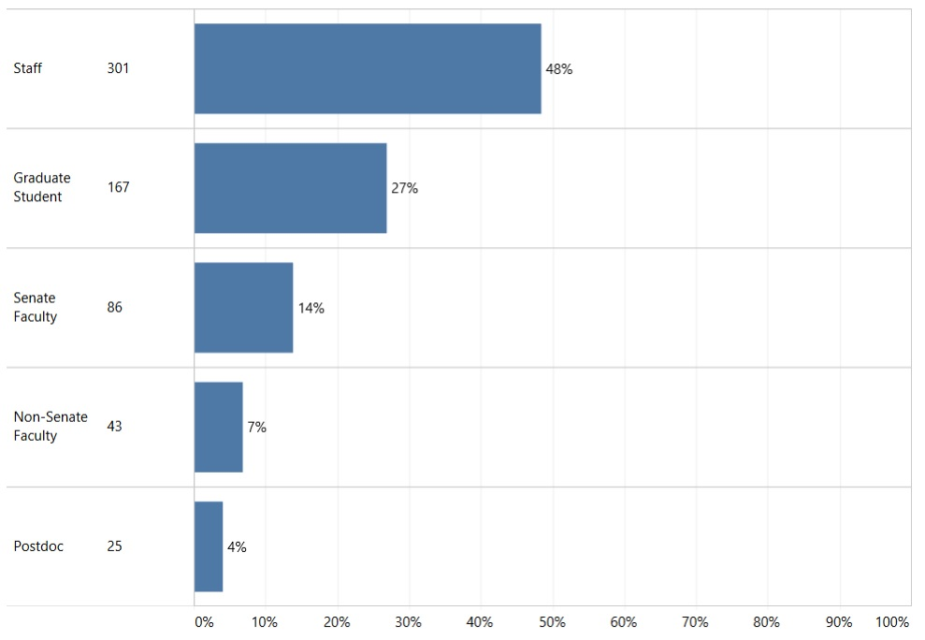
Figure 2. Respondent Division/Unit
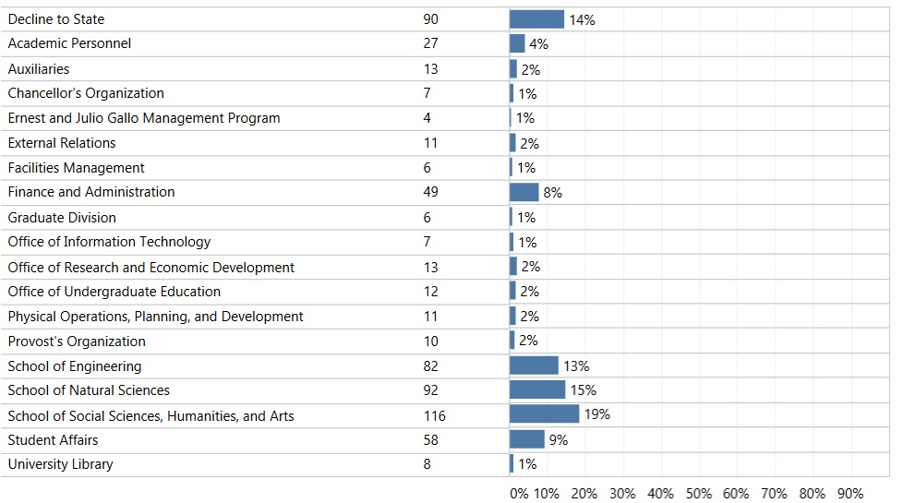
Your Well-Being
Campus Cares. Overall, 84% of respondents agreed that UC Merced cares about their well-being (Fig 3), indicating that the campus as a whole is generally conveying to respondents that their well-being is an important consideration.
Figure 3. UC Merced Cares About Well-Being
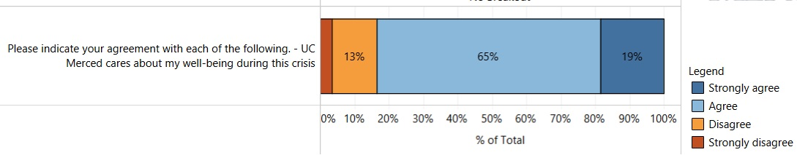
Mood. Respondent mood presented more of a mixed picture, as only 49% of respondents reported being in a “quite good” or “somewhat good” mood over the past week (Fig 4).
Figure 4. Mood Over the Past Week
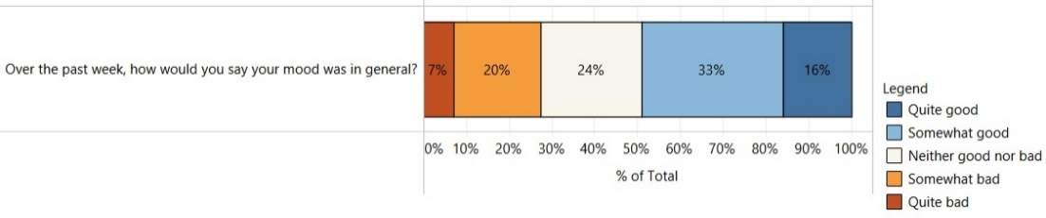
There was some variability across divisions/units such that we recommend unit/division leads view the data in the dashboard to investigate impacts that could benefit from deeper exploration (Fig 5). For example, within the Chancellor’s Organization, only 29% of respondents reported that they had been in a good mood over the past week, though we acknowledge that there were only 7 respondents and that we cannot necessarily attribute mood to one’s division/unit.
Figure 5. Mood Over the Past Week by Division/Unit
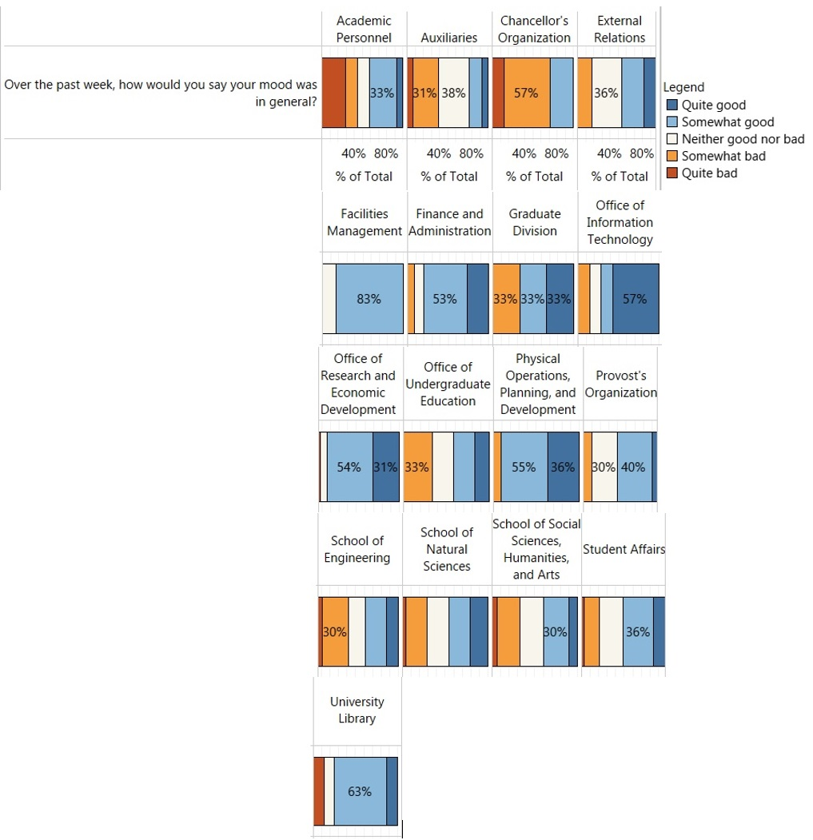
Connected to Campus Community. Overall, only 61% of respondents said they “strongly agreed” or “agreed” that they felt connected to the campus community during this crisis (Fig 6).
Figure 6. Feel Connected to Campus Community
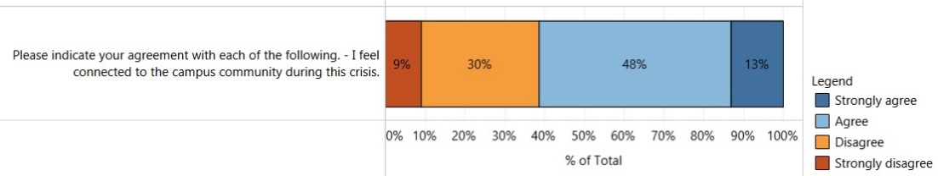
However, there were differences across respondent types (Fig 7). Only 48% of graduate students, 51% of non-Senate faculty, and 55% of postdocs strongly agreed or agreed that they felt connected. Conversely, 68% of staff and 73% of faculty felt connected. This pattern suggests that more work must be done to ensure that all members of the campus community feel connected during this time. This topic will be explored further in focus groups.
Figure 7. Feel Connected to Campus Community by Respondent Type
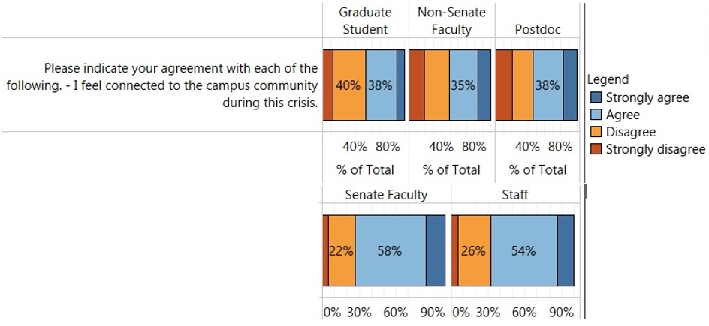
Resources. Of the four resources asked about on the survey, a large proportion of respondents did not know about or find many of them applicable (Fig 8). This suggests that campus leadership might consider additional ways to ensure the campus community is aware of resources that might be useful to them and to engage the campus community in their use. A better understanding of not applicable (NA)/not aware responses will be explored further in focus groups.
Figure 8. Use of Campus Resources with NA/Not Aware Responses
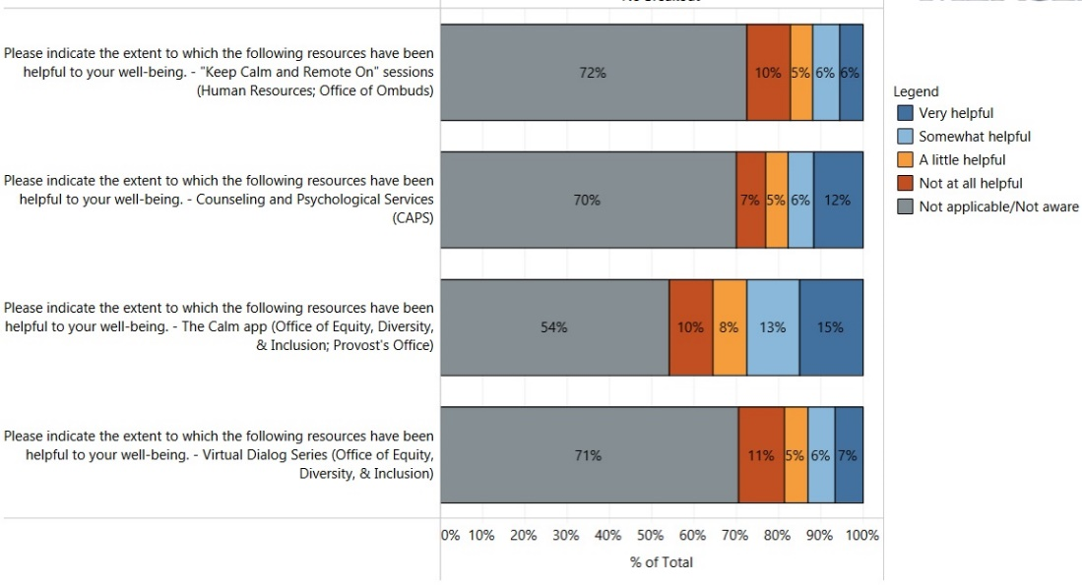
That being said, when not applicable/aware responses are excluded, it is clear that several resources have been helpful to those who used them – in particular, CAPS and The Calm App, with 60% and 61% of respondents, respectively, indicating that these resources were “somewhat” or “very helpful” (Fig 9). If not already in place, campus leadership could also consider other efforts to assess the effectiveness of campus resources to ensure they are meeting the intended outcomes.
Figure 9. Use of Campus Resources Excluding NA/Not Aware Responses
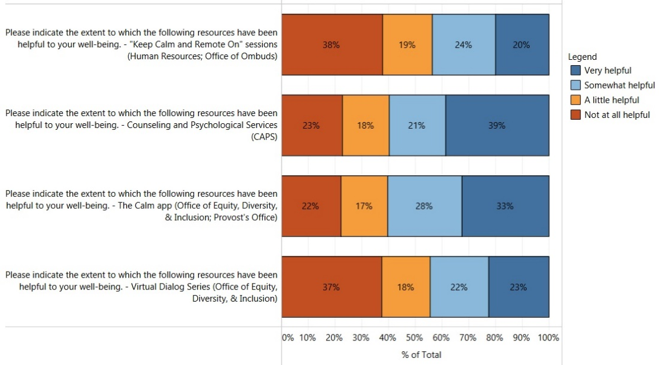
For graduate students, an additional question was asked about the Dean of Students Office resources. As can be seen from Figure 10, 68% of graduate students were not aware of or thought this resource was not applicable to them, suggesting that the campus may wish to consider additional outreach to ensure that graduate students are aware of and know how to access this resource.
Figure 10. Graduate Student Use of Resources with NA/Not Aware Responses
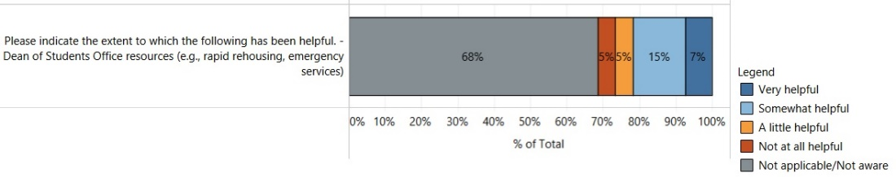
However, from Figure 11, of the graduate students who used this resource, most (69%) found it “somewhat” or “very helpful”.
Figure 11. Graduate Student Use of Resources Excluding NA/Not Aware Responses
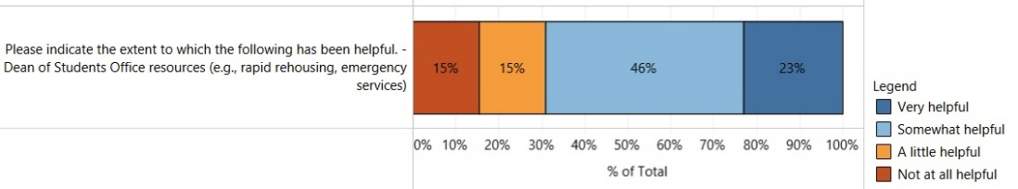
The qualitative responses present a more nuanced view of the impacts that COVID-19 has had on survey respondents. For example, even when individuals are aware of the availability of resources, they may not have the opportunity to use them.
Staff: I’m too busy to worry about my well-being; there are services offered, I know, but I don’t have time due to the unreasonable amount of work I have on my plate. If I focused on my much needed mental health, I will not be able to get done a portion of what I’m responsible for. I feel guilty for taking a dinner break.
Impacts of COVID-19. Excluding NA responses, several areas stood out as having a "a great deal” or “a moderate amount” of an impact on the campus community (Fig 12). Key impacts were in the areas of care – childcare (75%), elder/adult care (55%), and schooling for children (college students, 61%, or K-12 children, 84%). As the pandemic will continue to have impacts on care responsibilities, campus leadership will need to consider ways to support and accommodate members of the campus community as they continue to have additional responsibilities outside of their work and that likely impact mental health.
Figure 12. Impacts of COVID-19 Excluding NA Responses
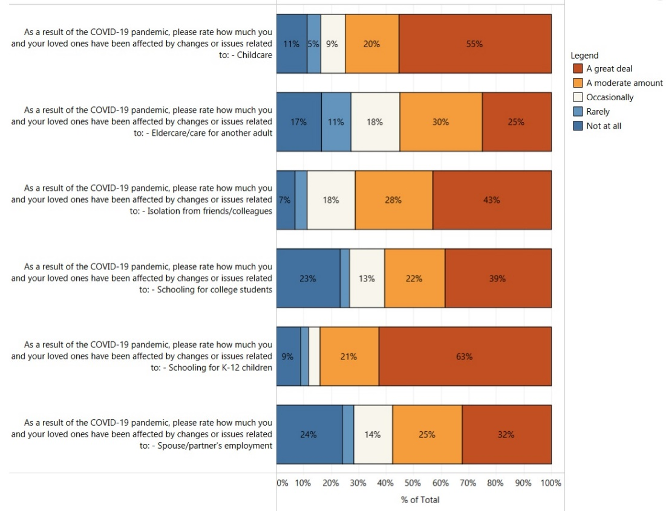
Respondents also reported isolation from friends and colleagues (71%; Fig 12). These responses appeared to vary by respondent type with graduate students, non-Senate faculty, and Senate faculty reporting rates between 76-77%, and with postdocs and staff reporting rates between 66-67% (Fig 13).

Figure 13. Impacts of COVID-19 – Isolation excluding NA Responses
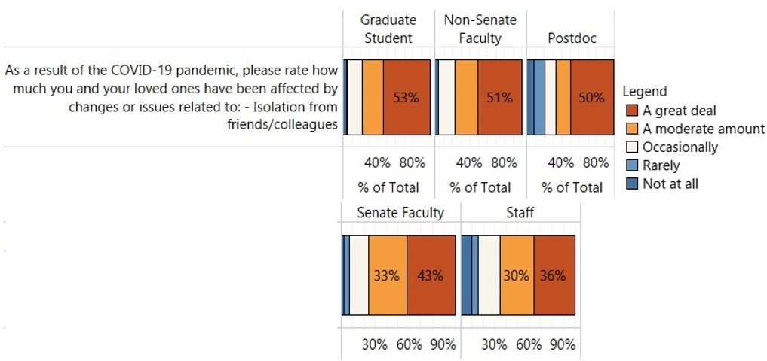
Feelings of isolation were also reflected in the qualitative responses. For individuals who live alone – and thus feel isolated from both their campus community and their loved ones – these feelings of isolation and their links to mental health are especially evident. These comments demonstrate the need for mental health care to be integrated into workplaces and continuous efforts to provide opportunities of connection for individuals feeling especially isolated.
Graduate student: Honestly, I live alone and my mental health is my biggest concern.
Staff: Find ways to boost employee morale – whether through Zoom meetings not related to work, contests via email, etc. Something to give employees a “boost” (emotional/mental) during this time.
This suggestion for finding ways to boost morale would help to not only provide employees with a space where they can step away from their workload, but to also facilitate connections with colleagues outside of work-related topics.
Finally, respondents reported spouse/partner employment (57%) as a key concern (Fig 12). Campus leadership might consider additional ways to recognize and support these impacts on members of the campus community. This topic will be explored further in focus groups.
In the context of work, areas of particular concern were compensation/salary and job security, with 67% and 66% of respondents reporting that they were “very concerned” or “concerned”, respectively (Fig 13). Fifty-seven percent of respondents also reported concerns with inequities in the merit/promotion process.

Figure 13. Impacts of COVID-19 – Compensation, Job Security, Inequities Excluding NA Responses
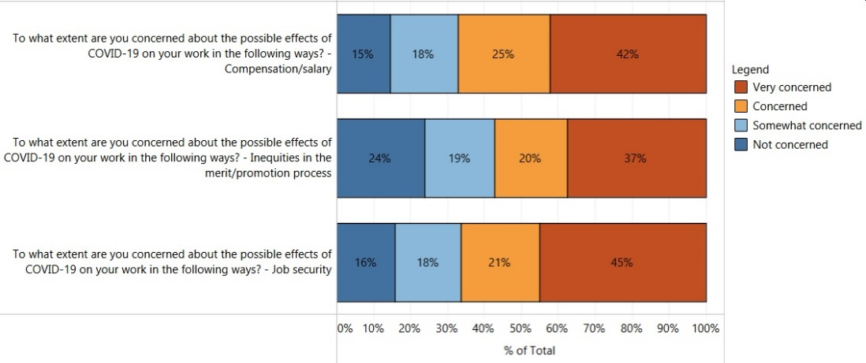
Focusing only on “very concerned” responses, some additional patterns emerge for particular divisions/units and respondent types. Regarding respondent type, for example, non-Senate faculty (53%), postdocs (56%), and staff (52%) were very concerned about job security relative to only 14% of Senate faculty (Fig 14).
Figure 14. Impacts of COVID-19 – Compensation and Job Security by Respondent Type Excluding NA Responses
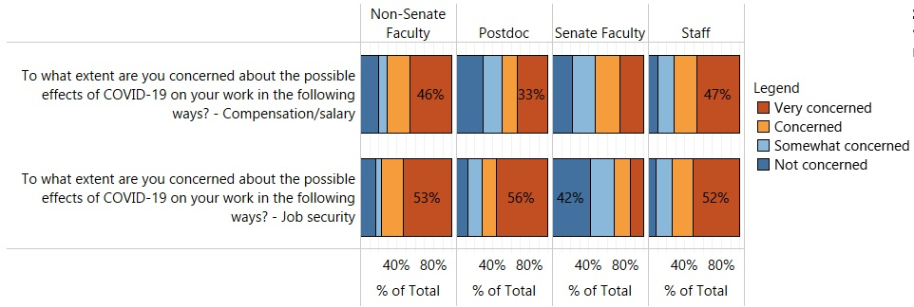
Regarding division/unit (Fig 15), for example, respondents who work in Auxiliaries (83%), Facilities (60%), Student Affairs (61%), and the University Library (71%) were particularly concerned about compensation/salary relative to other groups - though it is important to note that several of these divisions/units had very few respondents. We recommend that unit/division leads, in particular, examine response patterns for their units.

Figure 15. Impacts of COVID-19 – Compensation and Job Security by Division/Unit Excluding NA Responses
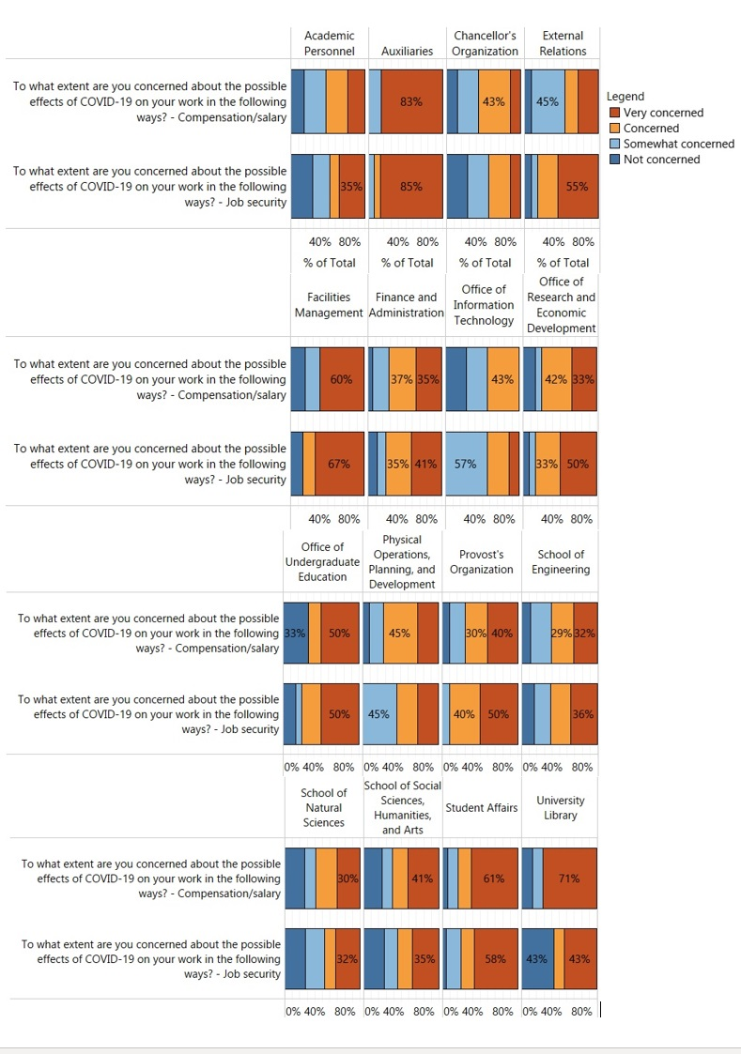
The qualitative responses also indicate that concerns around job security were a source of stress for all respondent types. It is important to highlight these concerns for groups whose employment status is already uncertain.
Non-senate faculty: As a non-tenured faculty member, the biggest concern is employment. My position was already precarious and now this crisis gives even more concerns.
Staff: Job protection for falling below 40 hours (due to childcare constraints) when not on an official leave status.
Work productivity can be impacted by the added obstacles of working from home, such as family care, and so employees may feel their jobs are at risk if they are unable to meet the hours or productivity typically expected of them.
For graduate students, job security concerns were manifest as concerns about losing funding (69%) and not finding a job after graduation (73%; Fig 16).
Figure 16. Selected Graduate Student Concerns Excluding NA Responses
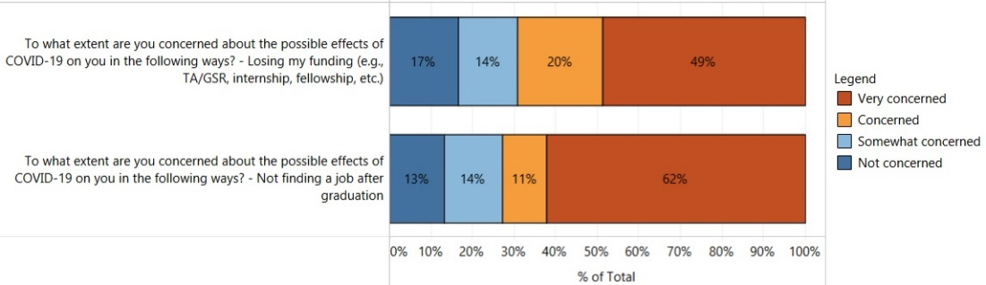
Regarding the latter, this pattern was particularly striking for graduate students in the School of Social Sciences, Humanities, and Arts – 80% were “very concerned” about not finding a job after graduation relative to 60% of students in the School of Natural Sciences and 51% in the School of Engineering (Fig 17). Though most students in each field have concerns, the COVID-19 pandemic appears to be exacerbating some longstanding concerns within particular fields.
Figure 17. Selected Graduate Student Concerns by School Excluding NA Responses
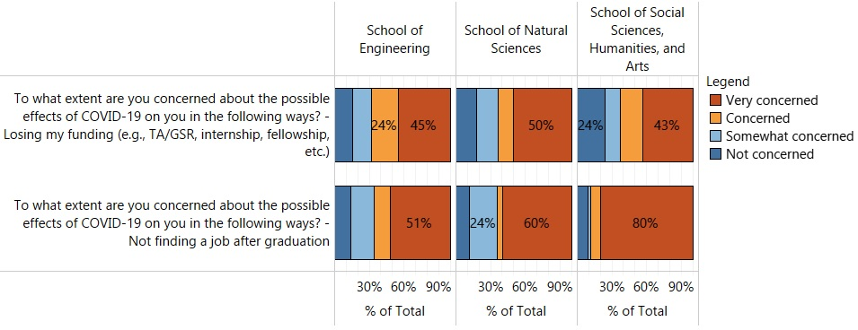
These patterns regarding job security suggest that clear and consistent communication and resources in these areas is essential. Next, we turn to additional impacts on work and workloads.
Your Work
Impacts of COVID-19 on Workload. From Figure 18, overall, 45% of respondents reported that they are currently expected to perform “somewhat more” or “much more” work compared to before the COVID-19 pandemic.
Figure 18. Current Expected Workload Compared to Before the COVID-19 Pandemic
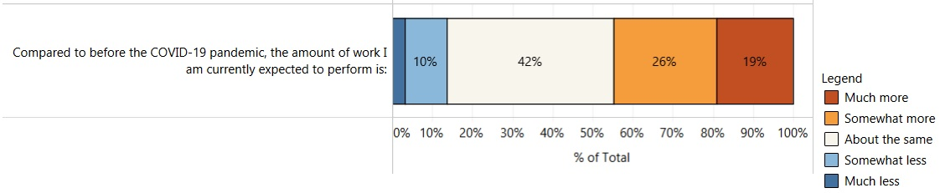Focusing only on “somewhat more” and “much more” responses, some additional patterns emerged for respondent type and division/unit. For example, 82% of non-senate faculty reported that they are expected to perform “somewhat more” or “much more” work than before the COVID-19 pandemic relative to senate faculty (53%), staff (48%), graduate students (31%), and postdocs (8%; Fig 19).
Figure 19. Current Expected Workload Compared to Before the COVID-19 Pandemic By Respondent Type
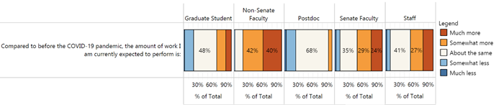As can be seen in Figure 20, there also appears to be variability in the amount of work that respondents are expected to perform across divisions/units. For example, respondents reporting “much more” or “somewhat more” at high rates were from Physical Operations, Planning, and Development (73%); the Provost’s Organization (70%); Graduate Division (66%); the Office of Undergraduate Education (58%); and the Chancellor’s Organization (57%). However, it is important to note that some departments/units had a small number of respondents. These patterns should be explored further by individual division/unit leads.

Figure 20. Current Expected Workload Compared to Before the COVID-19 Pandemic Across Division/Unit
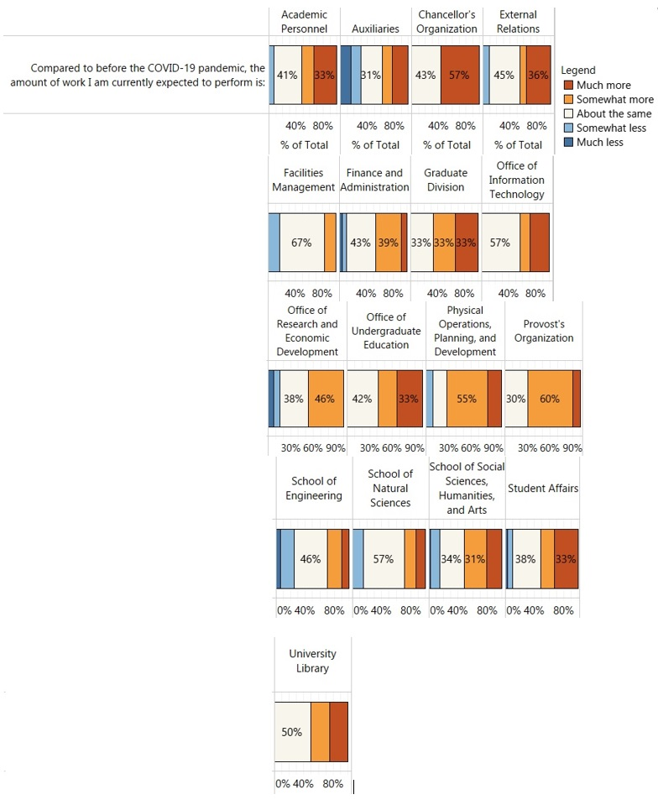
The qualitative responses also highlight issues regarding workload. Not only are all respondent types experiencing increased workloads, but they also made observations regarding the need for adjusted expectations of productivity amidst the pandemic.
Senate faculty: [Allow] me to slow down in my productivity and in my service roles, and clearly [communicate] that this is acceptable.
Graduate student: [Advise] graduate students that they shouldn’t be expected to uphold the same standard of work as they did before the pandemic.
Staff: Some departments and managers need to recognize that some work done remotely may not be done as efficiently or effectively as if we were in the office. That message needs to be out there more so employees don’t feel as if they will be disciplined for things outside of their control.
A common thread across comments such as these is not only recognizing one's own changes in productivity, but that there should be messaging from individual supervisors and departments that exemplifies flexibility and demonstrates an understanding for the change in efficiency and productivity.
Broadly, we recommend that leadership considers further exploring the differences in workloads across respondent groups to better understand what type of workload support may be needed among members of the UC Merced community. Increases in workload can negatively impact mental health and can do so in particular by limiting individuals’ ability to take time to address their mental health needs as they arise.
Positive Aspects of Remote Work. Though respondents have experienced challenges with workload overall, the quantitative data also indicates positive aspects.
Access to Reliable Internet, Equipment, and Technologies Need to Perform Job Duties. The majority of respondents indicated that they “agree” or “strongly agree” that they have the reliable Internet (85%), equipment (84%), and technologies (91%) needed to perform their job duties in the remote working environment (Fig 21).
Figure 21. Access to Reliable Internet, Equipment, and Technologies Need to Perform Job Duties Remotely Excluding NA Responses
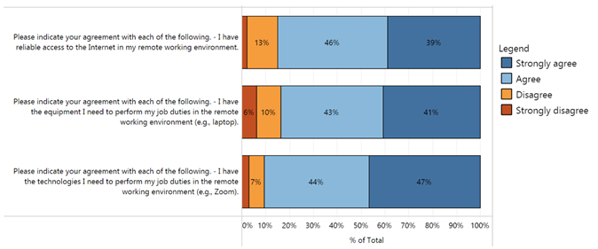Amount of Supervisor/Mentor Support and Contact. Additionally, respondents largely indicated that they “agree” or “strongly agree” that their supervisors/mentors are supportive of personal issues that may arise (89%), the amount of supervisor contact meets their needs (88%), and the amount of team contact meets their needs (89%; Fig 22).

Figure 22. Supervisor/Mentor Support and Contact Excluding NA Responses
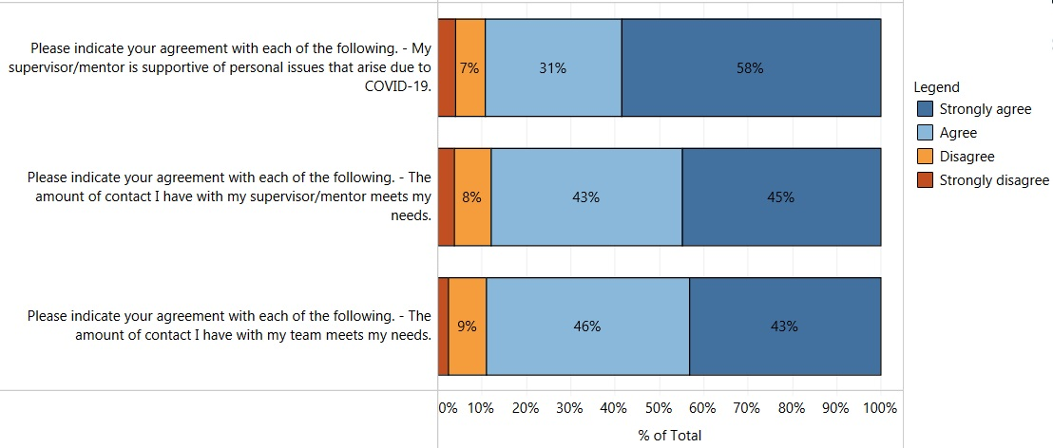Figure 23 disaggregates responses by respondent type. Most graduate student (85%), postdoc (88%), and staff (91%) respondents “agree” or “strongly agree” that the amount of contact with supervisors/mentors meets their needs. This was also true regarding the amount of contact staff members had with their teams (89%).
Figure 23. Supervisor/Mentor Support and Contact by Respondent Type Excluding NA Responses
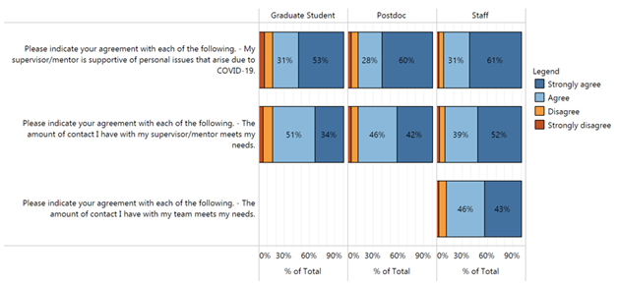While the shift to remote work has presented a number of obstacles and stressors, some appreciate the ability to work remotely. A number of qualitative responses expressed gratitude for not having the added stress of in-person work, which can pose health risks to individuals and their families.
Staff: I have appreciated not only the ability to work remotely but how remote work has been promoted and encouraged for any/all staff who can perform their duties remotely.
Other comments, such as the one below, note an increase in productivity due to the removed time constraints of having to commute to work.
Graduate students: I got my work done. I appreciated the lack of commute. I did two “online” presentations, completed my courses, served as a GSR, and made headway on my research.
While the pandemic has exacerbated mental health concerns for some, others have encountered positive effects within their specific department or team.
Staff: Departmental leadership telling staff it’s okay to not be okay, just do the best you can (I wish everyone heard that message).
Staff: I appreciate the team I am on and how we have come together to find solutions and not obstacles to the COVID-19 pandemic. We have, in no way, let this pandemic negatively impact our roles in reaching students and making them feel valued and appreciated.
Both responses indicate the importance of an individual team or unit showing care and understanding to the context within which employees must continue to operate, while also coming together to address the needs of the students they work with.
Graduate student: The resilience of our students as they shifted to an unexpected mode of learning in difficult situations.
There were comments, such as the one above, that acknowledged positive undergraduate student responses as a source of motivation for employees who worked with them.
Praise for the Office of Information Technology (OIT). It is also important to acknowledge units that have contributed to positive experiences with remote work. While the survey did not directly ask about the work of OIT, a several qualitative responses demonstrated a deep appreciation for the important role that OIT has played in easing the transition from in-person to remote work.
Senate faculty: I also appreciate how rapidly IT pulled together resources to assist our faculty and students.
Non-senate faculty: IT help desk and their ability to help remotely – SO WONDERFUL!!!
Staff: IT’s chat feature to assist with any IT issues while working remotely. It’s been very helpful and fast.
Challenges of Remote Work. While it is the case that many have found positive aspects to remote work, there are also specific challenges, which we discuss next.
Ergonomic Challenges. The quantitative data suggests that meeting the ergonomic needs of respondents is an important area for improvement. Specifically, only 48% (less than half) of respondents “agree” or “strongly agree” that their ergonomic needs are being meet in their remote work environment (Fig 24).

Figure 24. Ergonomic Needs Excluding NA Responses
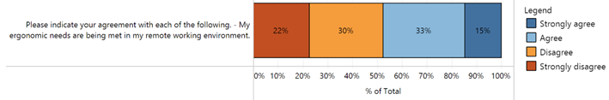Disaggregating across departments/units (Fig 25), there is substantial variability. For example, respondents with particularly high rates of disagreement (“disagree” or “strongly disagree”) that their ergonomic needs were being met were from the Office of Undergraduate Education (75%), the Chancellor’s Organization (71%), Student Affairs (64%), the Provost’s Organization (60%), and Graduate Division (60%). Though it should be noted that several of these departments/units had very few respondents. Meeting ergonomic needs will be examined in focus groups; however, we recommend that division/unit leads investigate strategies for meeting the ergonomic needs of their teams.
Figure 25. Ergonomic Needs by Department/Unit Excluding NA Responses
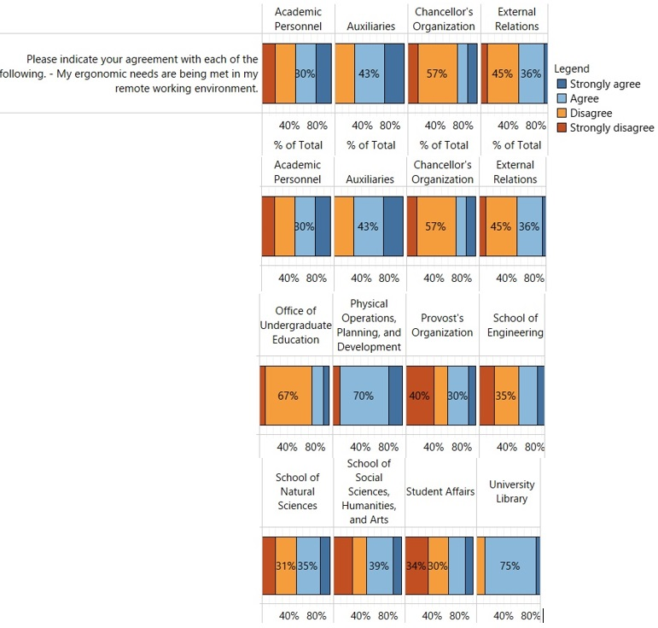
Effectively Mentoring Students. Overall, 78% of faculty indicated that they were “concerned” or “very concerned” about impacts of COVID-19 on their ability to effectively mentor students (Fig 26). Responses were similar for senate (78%) and non-senate (76%) faculty. Although it is not possible to distinguish how this concern may or may not differ regarding mentoring undergraduate versus graduate students, the data highlights the pervasiveness of this concern among the faculty. While focus groups will explore how faculty mentoring concerns may or may not differ as a function of student type, we recommend that leadership consider potential ways to help assuage this concern. One possibility might be a targeted communication for faculty containing guidance on how to virtually mentor students.
Figure 26. Mentorship Concerns Among Faculty Excluding NA Responses
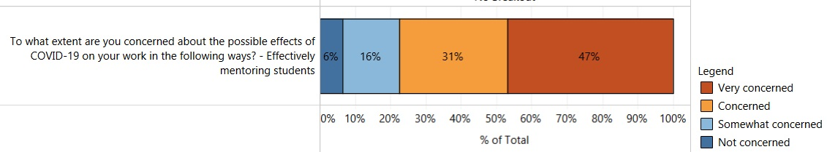Research Productivity. Seventy-eight percent of Senate faculty and 68% of postdocs were “concerned” or “very concerned” about their research productivity (Fig 27).
Figure 27. Research Productivity Concerns Among Senate Faculty and Postdocs Excluding NA Responses
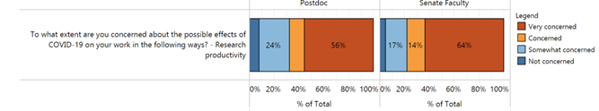
Additionally, 78% graduate students indicated that they were either “concerned” or “very concerned” about their ability to conduct research (Fig 28).
Figure 28. Ability to Conduct Research Concerns Among Graduate Students Excluding NA Responses
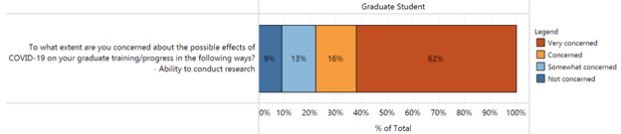
These concerns will be explored in focus groups to develop a deeper understanding and help campus leadership identify ways to support the UC Merced research community during this pandemic.
Professional Development. All respondents were concerned, although to varying degrees, about how COVID-19 may impact their ability to attend professional meetings (Fig 29). Specifically, 52% of non-Senate faculty, 72% of postdocs, 77% of Senate faculty, 44% of staff, and 78% of graduate students indicated that they are “concerned” or “very concerned”. We recommend that campus leadership consider how to best support professional development during this time.
Figure 29. Concerns About Attending Professional Meetings by Respondent Type Excluding NA Responses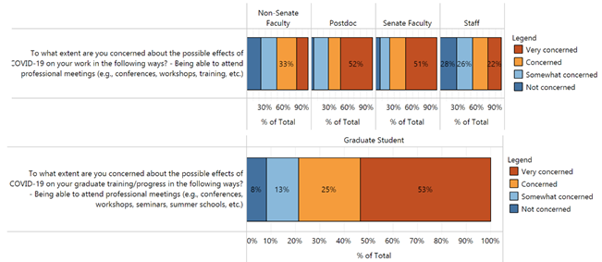In-Person Work Concerns. Concerns about returning to in-person work also emerged. Overall, 68% of respondents were concerned about returning to in-person work (Fig 30).
Figure 30. Concerns about Returning to In-Person Work Excluding NA Responses
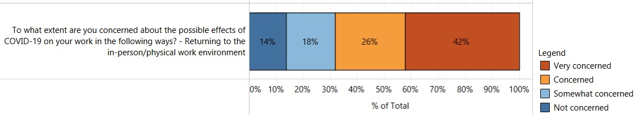When disaggregated by respondent type, 72% of non-Senate faculty, 69% of Senate faculty, 68% of staff, ad 56% of postdocs indicated that they were “concerned” or “very concerned” about returning to in-person/physical work environments (Fig 31).
Figure 31. Concerns about Returning to In-Person Work by Respondent Type Excluding NA Responses
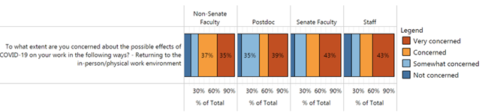
The qualitative responses shed more light on the nature of these concerns for faculty and staff.
Non-senate faculty: Starting the fall semester online, I don't want to do that, but I'm also nervous about being in a classroom with my students, so I feel like it's a catch-22.
Senate faculty: I am a high risk for complications from COVID19 if infected, despite taking care of my health. I am concerned about pressure to get back to normal next year despite ongoing risks. I don't know how to assess or balance these risks.
In addition to health risks, there are also logistical concerns such as childcare, particularly for children whose schools may not resume in-person learning.
Staff: I am concerned about the possibility of returning to the office when my children are still remote learning; or in the summer when they would typically go to camp which is now cancelled.
Staff: If I am required to return to work and my son has to still be home schooled I do not have anyone to watch him.
Graduate students also had concerns about returning to in-person work - 48% said they were “concerned” or “very concerned” with being asked to do things as a TA/GSR that might make them feel unsafe (Fig 32).
Figure 32. Graduate Student Concerns About Feeling Unsafe Excluding NA Responses
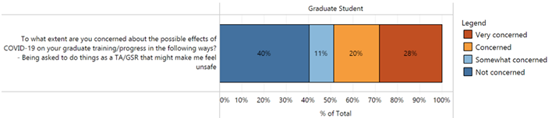Qualitative responses from graduate students suggest that these concerns may be specifically related to returning to in-person work, and, in particular, worries that they must defer to their advisor or instructor of record.
Graduate student: I am worried that some students will be protected more than others (undergrads vs. grad students), and that grad students will be forced to come to campus to fulfill TA duties or research duties.
Graduate student: [My concern is] that a situation will arise where I feel uncomfortable with the amount of risk (risk as carrier to very vulnerable family members) as a TA and the instructor doesn't allow for remote work. I'd drop out/pay my own tuition than accept that proposition.
Graduate student: I am worried about the lack of consistency between departments regarding returning to in-person work. While it has been stated that no one can be forced to return to work, I worry that some supervisors will present it as non-optional.
Remote Instruction. The survey also contained questions for faculty and graduate students regarding remote instruction. The present report will not explore this topic; however, interested readers can consult a narrative summary specifically devoted to this topic at this link.
The Campus Response
Management of Pandemic. Respondents overwhelmingly “agree” or “strongly agree” (88%) that UC Merced has managed the COVID-19 pandemic well (Fig 33).
Figure 33. of Campus Management of COVID-10 Pandemic Excluding NA Responses
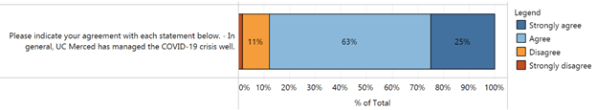This positive sentiment was also observed in the qualitative responses, with positive feedback regarding both the speed with which the campus transitioned to remote work and its efficiency in doing so.
Senate faculty: I think our initial move to teleworking was awe-inspiring – I am so impressed it was pulled off with so few issues. I have also appreciated the willingness to protect staff compensation.
Staff: Everyone followed the same order from the top instead of each department trying to figure it out. I came from another campus and it seems that decisions were not clear and no one was stepping up to make one uniformed decision.
Many comments also demonstrated relief and appreciation that the campus swiftly responded to the needs of undergraduate students.
Graduate student: I spent less energy worrying about students affected by housing because UC Merced’s campus closures were closely monitored and managed.
Senate faculty: I really appreciated the laptops and internet technology that was sent to my students. So happy my students were supported.
Communications. Respondents were also generally satisfied with campus communications. The majority “agree” or “strongly agree” that UC Merced’s communication about the COVID-19 pandemic has been appropriately comprehensive (79%), frequent (88%), and timely (82%; Fig 34).
Figure 34. Campus Communications Regarding the COVID-10 Pandemic Excluding NA Responses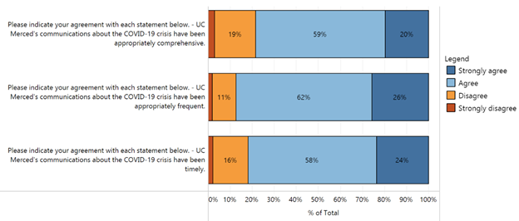
Some of the positive comments regarding campus communications demonstrated that individual units and departments were doing a good job of communicating to their employees. When supervisors and department heads make a clear effort to communicate efficiently, it is greatly appreciated by their employees and can even have a positive impact on employee ability to complete work remotely.
Senate faculty: I greatly appreciate the communications that have come from my Dean and department chair. Both have been working tirelessly to provide support to our faculty and students. Their communications are concise, useful, and reassuring.
Staff: I appreciate the updates and information. My immediate supervisor and team have been very responsive and helpful as well. I am not concerned about my ability to do my job remotely.
Regarding specific modes of communication, the majority of respondents indicated that all modes noted on the survey were “somewhat useful” or “very useful” (Fig 35). For instance, 85% of respondents indicated that the Weekly Briefing from the Chancellor was “somewhat useful” or “very useful”.

Figure 35. Perceived Usefulness of Campus Communication Modes During the COVID-10 Pandemic Excluding NA Responses
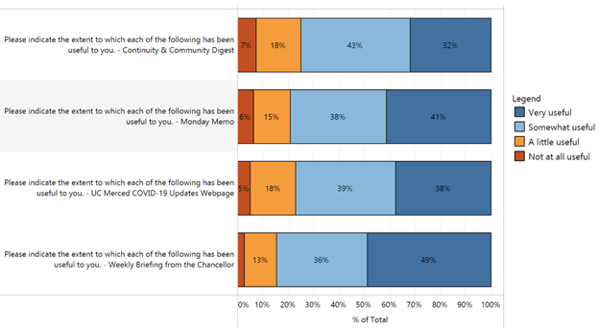
Other qualitative responses indicated that the COVID-19 resources page was particularly helpful, though also noting that communications were scattered and overwhelming at the beginning but have since improved.
Staff: I’m glad that the UC Merced webpage now includes all of the resources the campus is providing. For awhile there, I couldn’t keep up with all of the emails.
While the comments regarding campus communications were largely positive, several responses highlighted areas of improvement. It is important to note that while all respondent types had feedback on improving campus communications, postdocs expressed unique concerns about needing to seek information out themselves because it was not communicated to them. It is important to recognize the unique spaces that certain groups, such as postdocs, occupy and to ensure that they are not being left out of important communications, as these responses suggest.
Postdoc: Communicate with your postdocs and understand the disproportionate impact these changes have on their health, well-being, and security in the academic system, by reaching out and providing resources to them and keeping them informed of developments within the university related to COVID.
Postdoc: Put time and resources into helping your contingent faculty, including postdocs, and communicate more readily with them instead of expecting them to piece together information from occasional emails and the publicly available websites.
Next, an issue that was apparent across all groups was a lack of information on future decisions.
Graduate student: Keep us updated on decisions being made within the university, e.g. whether classes will be in person or online in the Fall. This causes a lot of uncertainty for graduate students and postdocs who are trying to figure out where they need to be physically be in the Fall. Even if definitive decisions have not been made, letting us know where the process is at would be helpful.
Staff: Provide transparency as circumstances allow. I believe folks are more worried about the uncertainty that prevents them from making confident decisions (I.e. living situation/leases, seeking employment to cover unexpected costs, planning financially responsible approaches to life expenses, etc.).
These and other comments express uneasiness at not knowing what decisions were being made. Although there were positive comments regarding the timeliness of some announcements, others expressed uncertainty at being completely left out of conversations taking place amongst leadership. Respondents often felt left in the dark, not knowing at all what to expect in the coming months. Campus communication will be explored further in focus groups.
For more information about the People First Workgroup, including focus group efforts, please visit this webpage.

A narrative summary regarding responses to questions about remote instruction can be found at this link.
Similar information was collected from undergraduate students on the 2020 University of California Undergraduate Experience Survey (UCUES). Interested readers can view the narrative summary at this link.
A dashboard of quantitative responses is publicly available at this URL. Note that throughout this report, percentages in figures may not sum to 100% due to rounding error.
To honor our commitment to survey respondents that we would protect their privacy, cell sizes less than 5 in the quantitative responses are not presented. Additionally, any qualitative (open-ended) responses that are shared have been reviewed to ensure that respondent identities are cannot be ascertained.
Resource only applies to graduate students and postdocs.
Minor grammatical edits have been made to the qualitative responses in this report for clarity and brevity.
Bars are only displayed for respondents who received this question on the survey.
Bars are not displayed when group sizes were less than 5 to protect respondent privacy.
This question was only presented to senate and non-senate faculty and was therefore not answered by any of the other respondent types.
This survey was distributed prior to the campus announcing a hybrid model for remote instruction in the Fall. These comments reflect the uncertainty around those decisions as they were in the process of being made.

